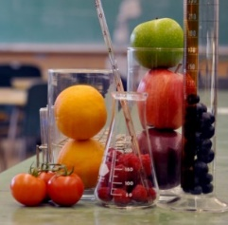
Kitchen Chemistry and Snackable Science
Spring Semester 2020

Red Cabbage Chemistry
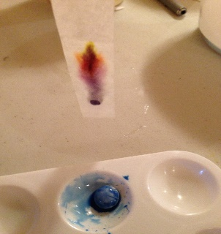
Red cabbage is a very good pH indicator. It contains a pigment called anthocyanin, which changes color when it comes in contact with acids or bases. Watch the Science Guys to learn the process and then test your own solutions to create a pH rainbow.
https://youtu.be/I18K2upEHLc
Candy Chromatography
Ever wondered why candies are different colors? Bags of M&Ms or Skittles contain candies of various colors. The labels tell us the names of the dyes used in the candies. But which dyes are used in which candies? We can answer this by dissolving the dyes out of the candies and separating them using chromatography. Follow this link to for the Candy Chromatography directions and video.
https://learning-center.homesciencetools.com/article/candy-chromatography-science-project/
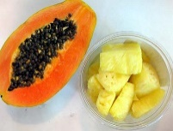
Fruit Enzymes
Did you ever notice on the Jello box that it is recommended to avoid adding certain fruits to the Jello? Why? Follow the link to the experiment.
https://teachbesideme.com/fruit-enzymes-gelatin-experiment/?utm_term=2017-02-19&utm_content=bufferd1a07&utm_medium=social&utm_source=pinterest.com&utm_campaign=buffer&fbclid=IwAR0Qv7zLBf5Y1rERzC4CbUw1UhQ5zkfdKn7RV1E6TjdRjWAPsBbk7zm-eKs
Check out the Science Buddies link for a great explanation how gelatin sets and how proteases (enzymes) work.
https://www.sciencebuddies.org/science-fair-projects/project-ideas/FoodSci_p004/cooking-food-science/which-fruits-can-ruin-your-gelatin-dessert?from=Blog#procedure
Ice Cream in a Bag
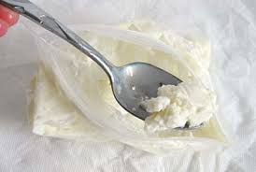
https://www.thoughtco.com/how-to-make-ice-cream-in-a-bag-602195?utm_source=pinterest&utm_medium=social&utm_campaign=shareurlbuttons_nip&fbclid=IwAR2Vj_-IN3DESxA3q5gbx1gbGEA25qowAEnmiWOO6ipAhixPLQr0ZwUh7NM
Food Science-Product Development (Ice Cream!)
https://www.youtube.com/watch?v=qbXALQ71P0U
Careers in Food Science and Technology Information Links and Videos
https://nfs.tamu.edu/home/academics/undergraduate-programs/food-science-and-technology/careers-in-food-science/
https://www.topuniversities.com/student-info/careers-advice/what-can-you-do-food-science-degree

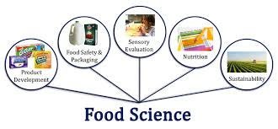

What is food Science? https://youtu.be/_bJYav37-zw
Food Scientist and Technologists
https://youtu.be/cWbaZEIe7GQ
https://youtu.be/ULaw7GNjE6Y
https://youtu.be/FQ2WMg6rs2s

