Introduction and Overview for the Teacher

This laboratory centers on the theory and practice of correlating molecular characteristics with evolutionary relationships among species. In this protein fingerprinting activity your students will move beyond DNA to explore proteins as an indicator of evolution, and use the technique of electrophoresis to compare protein profiles of closely and distantly related species of fish. Molecular biology has given us strong evidence that all of the diverse forms of life evolved from a common ancestor and also provides a plausible mechanism for the emergence of new traits. You and your students will be amazed at what you discover!
Intended Audience

It is our goal to provide biotechnology curricula and activities that integrate seamlessly into existing high school and college biology curricula, textbooks, and lab activities. This protein fingerprinting activity can stand alone, or complement the lessons and activities in our DNA fingerprinting, PCR-DNA amplification, and bacterial transformation kits. All Biotechnology Explorer kits and curricula are designed to deepen student understanding of concepts, techniques, and issues current in molecular biology and biotechnology.
Curricular Synergy, Fit, and Related Topics

- Molecular biology
- Biotechnology
- Biology
- Genetics
- Evolution

Recommended Student Background

Prior to this activity, your students should have some familiarity with the following concepts. Please read through these sections and cover these concepts with your students before beginning the laboratory. Answers to the questions and considerations posed throughout the student laboratory activities are derived from the background material presented in the Teacher's Guide.
- Darwinian theory of evolution
- Phylogenetic relationships
- DNA's genetic instructions expressed as proteins
- Commonality of DNA chemical structure and code in all organisms
- DNA mutation: kinds, causes, and effects
- Protein synthesis: DNA--~ RNA--> Protein
- Protein structure: primary, secondary, tertiary and quaternary
- Protein functions: enzymatic and structural
- Major proteins in muscle
- Electrophoresis: basic theory and SDS-PAGE
- Microscale units of measure
- Use of micropipets

Expected Outcomes

Following this laboratory your students should be able to:
Explain how polyacrylamide gel electrophoresis gives information about proteins
Describe how DNA mutations might lead to new traits over time Interpret protein profiles as molecular evidence for evolution Compare phylogenetic relationships with protein gel data
Apply the framework of molecular biology to understand evolution: DNA-)RNA-4Protein-Jrait
Propose a molecular mechanism to explain evolution

Activity Timeline

The three laboratory sessions are designed to be carried out in consecutive 50 minute periods. We recommend at least one day be added in advance to set the stage for this laboratory and at least one day be added at the end for discussion and student presentations of their results and interpretations.

Laboratory Day 1 Sample preparation - muscle protein extraction
Laboratory Day 2 Electrophoresis - load, run and stain polyacrylamide gels
Laboratory Day 3 Gel preservation; analyze and interpret results

Safety Issues

Precast polyacrylamide gels are safe and nontoxic. However, as standard practice, gloves, laboratory coats and goggles should always be worn by students throughout any laboratory activity.

Electrophoresis combines liquid and electricity and, therefore, presents a potential electric shock hazard. Proper use of equipment prevents this risk, but students must be made aware of the possibility and taught to handle equipment as instructed.

Students with known or suspected allergies should avoid all contact with shellfish samples.

Background and Fundamentals for Students

We recommend that your lecture(s) for this activity cover the topics discussed below. These concepts enrich student understanding of this laboratory.

The basis of this investigation: Students will use polyacrylamide gel electrophoresis to compare protein profiles derived from muscle tissue of different fish. Since proteins are specified by DNA sequences, as genetic (DNA) changes occur and pass from generation to generation, so do protein composition and organismal form change over time. To some degree, genetic similarities and differences can be detected and inferred from such electrophoretic protein profiles.

The hypothesis for this activity: The closer that two species are placed on an evolutionary tree based on morphological characters, the more similar their protein fingerprints will be.

The Molecular Basis of Evolution

Genetic evolution can be defined as the change in a gene pool (collective DNA of a species) over time. Alterations in DNA, called mutations, can alter proteins so that they function differently. These changes can lead to novel traits and generate diversity- individual differences among members of a population. Occasionally, a genetic mutation will alter a protein's structure to confer a functional advantage, enhancing an organism's survival in a particular niche, environment, or predator-prey relationship. Thus, genetic diversity makes evolution possible, since natural selection favors some individuals and not others, and this leads to changes in the composition of the gene pool overtime. DNA provides both for the continuity of traits from one generation to the next and accounts for the variation that can lead to differences within a species - and even to entirely new species. As Francis Crick, one of the discoverer's of the structure of DNA, said of his and James Watson's finding:

"We have discovered the secret of life." Francis Crick, Eagle Pub, Cambridge, 1953

The scientific theory of genetic evolution is based on the assumption that all life evolved from a common single-celled ancestor, through modification and diversification of earlier lineages into the forms that exist today. This theory is strongly supported by the discovery that a great deal of DNA sequence similarity exists among the genes of all modern-day organisms. For example, scientists were astounded to discover that the same family of genes (Hox genes) controls the embryonic development of animals as diverse as fruit flies, zebrafish, and humans.

"At the level of embryology we are glorified flies." Matt Ridley, Genome, 1999

The high levels of gene sequence similarity among diverse organisms can only be due to common ancestry, or homology. (This term is also used in reference to anatomical structures with a common derivation, such as primate hands, bat wings, and whale flippers.) Complex proteins in higher organisms have evolved by the shuffling and alteration of functional protein domains that originated in ancient life forms. Families of ion channels, gene activators, gene replicators, muscle proteins, and other functions are found in organisms everywhere, including those deep in the sea, underneath rocks, and even flying above us in the sky.

Human evolutionists have long argued over which primate is more closely related to us, the chimpanzee or the gorilla. With modern techniques for analyzing DNA, chimpanzees have been shown to share 98.4% of their DNA with humans, slightly more than either does with the gorilla (King and Wilson 1975).
Traditional classifications of organisms, including kingdom, phylum, class, order, etc., have been based primarily on morphological characteristics-traits that can be seen with the unaided eye or microscope. Molecular biology allows us to reassess these classifications with a deeper knowledge of the common genetic constitution of all organisms. During this laboratory activity your students will explore evolution at its very roots-by looking at the genetically determined molecules that give organisms their traits.
The Molecular Framework of Biology DNA->RNA-+PROTEIN-+Trait
DNA has been a primary focus of research recently, but the ultimate function of DNA is to specify what proteins are made. In fact, recent studies of the genome sequences of humans and other organisms have revealed that the number of proteins expressed by a species contributes more to its complexity than does the number of genes (Jasny and Kennedy 2001, International Human Genome Consortium 2001). Protein molecules perform a stunning variety of functions, from catalyzing chemical reactions to forming the structures of our body. Universally, every living cell requires specific enzymes for the thousands of chemical reactions that maintain life. Each enzyme is a protein with a unique sequence of amino acids, which is specified by a gene with a unique DNA sequence.
Proteins also form structural units such as cartilage and muscle tissue. For example, the contraction of muscle results from the interaction of two main proteins, actin and myosin. Like enzymes, muscle proteins such as actin and myosin are specified by genes with unique DNA sequences. Both actin and myosin and the unique structures into which they are organized are conserved among all animals, no matter how diverse. This conservation implies that the encoding DNA sequences have changed little through evolutionary time.
Just as similarities of structures indicate a common descent, variations and differences indicate divergence on the evolutionary tree. In this laboratory, students generate muscle protein fingerprints from several different species of fish and use them to infer evolutionary relationships. Before giving some background on fish evolution, we will provide more detail about the types of proteins found in muscle tissue.
Muscle Proteins
Our most familiar daily movements, from walking to simply breathing, are driven by the interactions between specialized proteins in our muscle fibers. The basic contractile elements of the muscle cells are the myofibrils that are bundled into muscle fibers. Each myofibril consists of a linear series of contractile units called sarcomeres.

Z Line
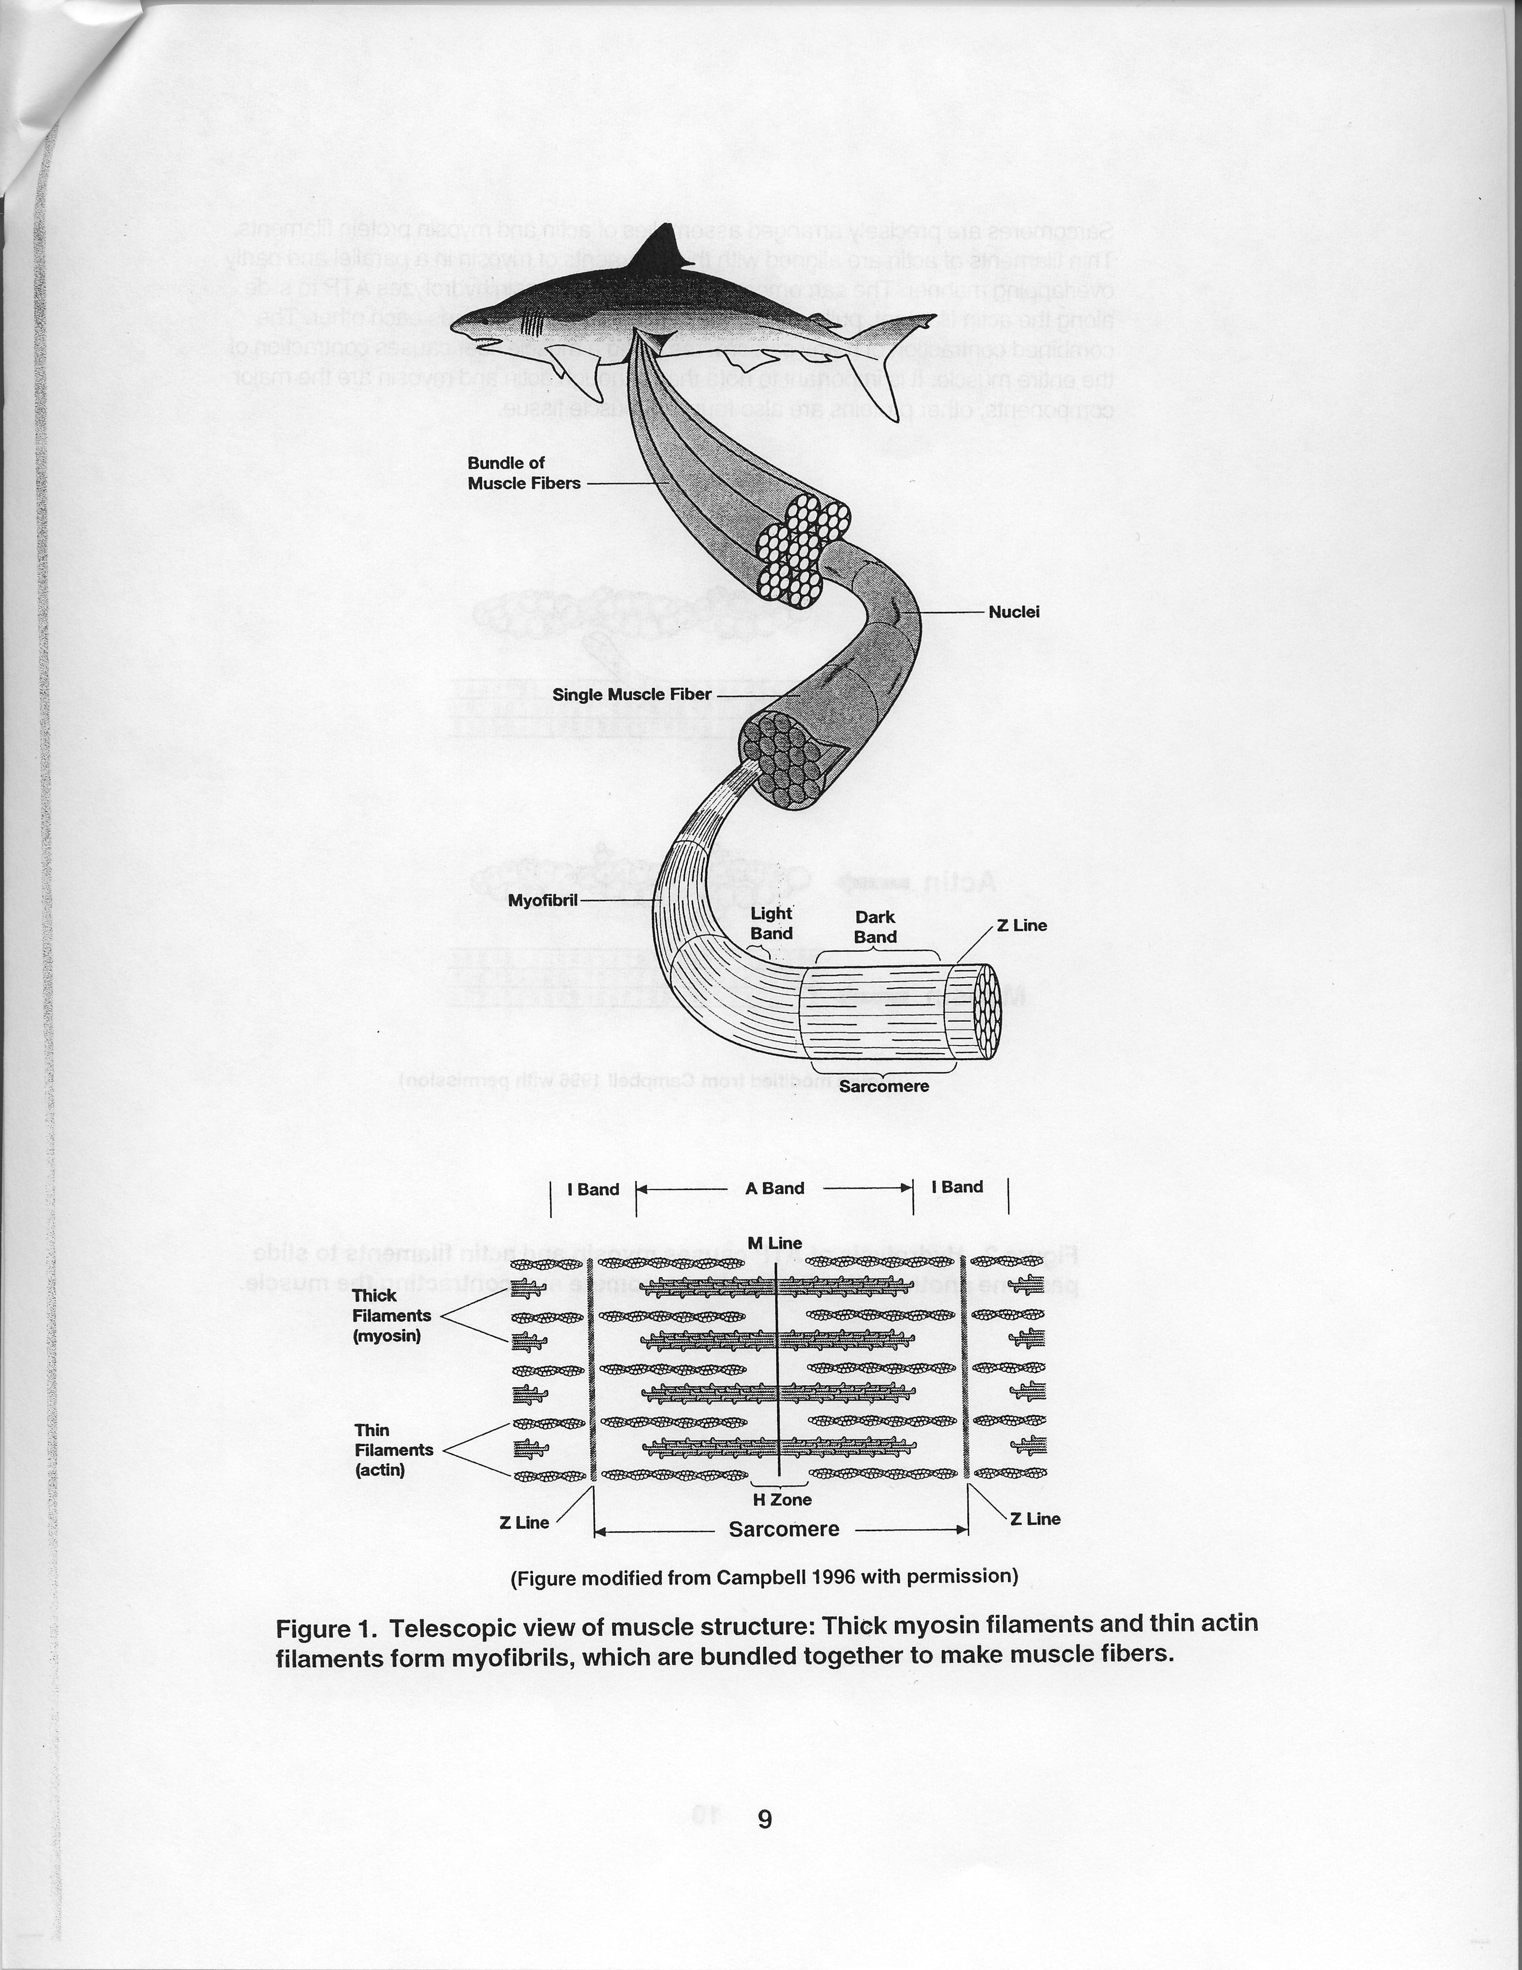
(Figure modified from Campbell 1996 with permission)
Sarcomeres are precisely arranged assemblies of actin and myosin protein filaments. Thin filaments of actin are aligned with thick filaments of myosin in a parallel and partly overlapping manner. The sarcomere shortens when myosin hydrolyzes ATP to slide along the actin filament, pulling the ends of the sarcomere towards each other. The combined contraction of many sarcomeres along a muscle fiber causes contraction of the entire muscle. It is important to note that, although actin and myosin are the major components, other proteins are also found in muscle tissue.

Actin
Myosin
(Figure modified from Campbell 1996 with permission)
Figure 2. Hydrolysis of ATP causes myosin and actin filaments to slide past one another, shortening the sarcomere and contracting the muscle.
Other Muscle Proteins

Numerous proteins besides actin and myosin are also required for muscle contraction (see table below). While actin and myosin are highly conserved across all animal species, other muscle proteins show more variability. These variations in an organism's muscle proteins may reflect refinements of muscle function and performance that are adaptive to particular niches, environments, or physiological stresses.

Characterized muscle proteins, in order of decreasing size, adapted from Alberts et al. 1994.

Protein | MW (in kD) | Function
titin | 3000 | centers myosin in sarcomere
dystrophin | 400 | anchoring to plasma membrane
filamin | 270 | cross-links actin filaments into a gel
myosin heavy chain | 210 | slides actin filaments
spectrin | 265 | attaches filaments to plasma membrane
M1/M2 | 190 | myosin breakdown product
M3 | 150 | myosin breakdown product
C protein | 140 | myosin breakdown product
nebulin | 107 | regulates actin assembly
a-actinin | 100 | bundles actin filaments
gelsolin | 90 | fragments actin filaments
fimbrin | 68 | bundles actin filaments
actin | 42 | forms filaments
tropomyosin | 35 | strengthens actin filaments
troponin (T) | 30 | regulates contraction
myosin light chains | 24, 17, 15 | slide actin filaments
troponin (I) | 19 | regulates contraction
troponin (C) | 17 | regulates contraction
thymosin | 5 | sequesters actin monomers

In this protein fingerprinting laboratory, actin and myosin will be present in all species but the presence of other proteins will be more variable. Students will compare the variable proteins of the different fish samples to assess evolutionary relatedness among species. Once students have carried out this analysis, they can compare their results with evolutionary trees based on morphological data.

Next, we will outline fish evolution before covering how protein fingerprinting works.
Evolution and Classification of Fishes

To help with the selection of fish for the laboratory and to aid interpretation of the molecular data, students need to have some understanding of fish evolution. The evolutionary charts below will aid you in selecting appropriate varieties. The idea is to compare both closely related and distantly related fish. We recommend that you, or your students, research additional information on the evolutionary histories of fishes, using the Internet and biology and zoology books. A list of useful references is included in the Further Reading list at the end of this manual.
Evolutionary trees
An evolutionary tree shows the evolutionary lineages of different species over time. The following evolutionary trees are not precise or drawn to scale but are intended as a reference for selecting a diverse mix of fish samples that may be available in your region. Figure 3 shows the relationship among a number of animal phyla.
Annelids (worms)
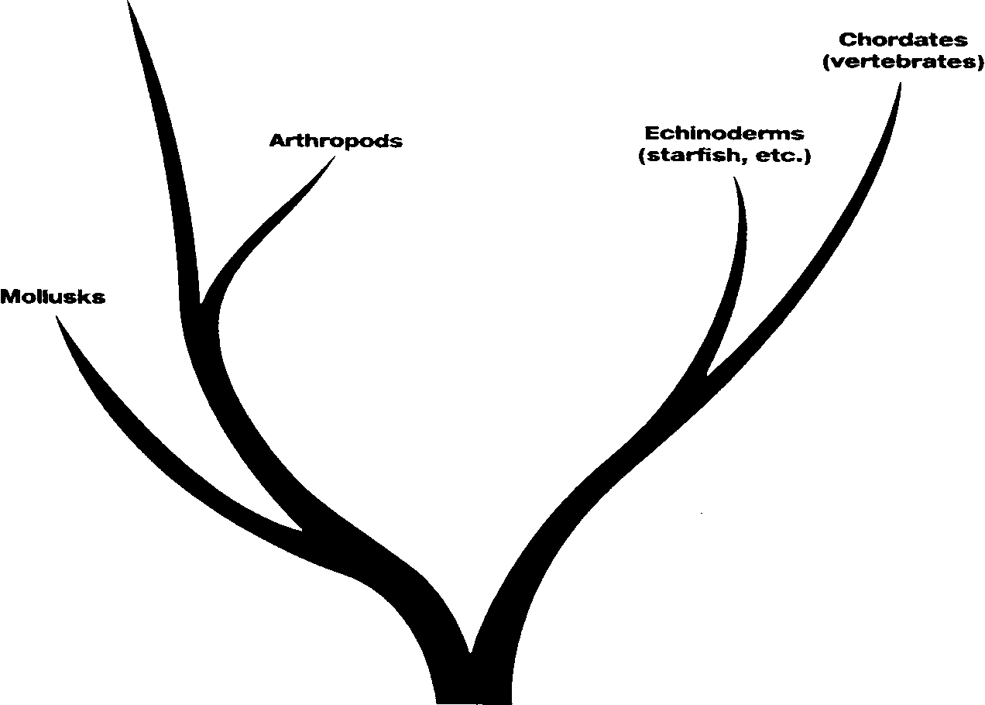
Metazoa
Figure 3. Evolutionary tree showing the relationships among the vertebrates (chordates, including all fish), mollusks, worms, echinoderms, and arthropods.
The modern fishes are divided into the classes Chondrichthyes (cartilaginous fishes) and Osteichthyes (bony fishes), with the lampreys and hagfishes in the separate class Agnatha (jawless vertebrates) that diverged earlier from the ancestral fishes. The Chondrichthyes include the sharks and rays, and the Osteichthyes, include all other modern fishes. Below are brief descriptions of some of the major fish groups, in order from most ancient to most recently diverged.
Agnatha. Lampreys and hagfishes are eel-like, jawless fishes with parasitic and scavenging lifestyles. They do not have scales or paired fins. They evolved from the earliest vertebrate ancestor before the jawed fishes appeared and diversified. The fossil record for Agnatha stretches back nearly 500 million years.
Chondrichthyes. Sharks, rays, and skates belong to this class. Their cartilaginous rather than bony skeletons reflect a more evolutionarily ancestral state. Their skin is thick and without true scales, and they do not have swim bladders or lungs.
Osteichthyes. The bony fishes are the most diverse class of fish. The class is characterized by having bony skeletons, true scales, paired fins, and movable rays in their fins and tail. Osteichthyes are divided into two subclasses, the lobe-finned fish (Sarcopterygians) and the ray-finned fish (Actinopterygians).
Sarcopterygians are the fish most closely related to modern amphibians, reptiles, birds, and mammals, and this subclass includes the lungfish and coelacanth. Coelacanth were thought to have become extinct at about the same time as the dinosaurs, until a live specimen was found in 1938 (Glausiusz 1999)!
Most modern fish are members of the ray-finned, Actinopterygian subclass.
Sturgeons, bowfins, and gars are considered relic bony fishes. There are about 50 species of these relic fish extant around the world today, although the fossil record shows there were many more in the past.
Teleosts. The remainder of the bony fishes are in the subdivision Teleostei, which includes 42 orders and over 23,000 species. The orders that include herrings and anchovies and the eels are considered specialized offshoots of the teleosts and comprise about 6% of the subdivision.
Other subdivisions of Teleostei:
Superorder Ostariophysi
Order Cypriniformes (minnows, carps)
Order Siluriformes (catfish)
Superorder Protacanthopterygii
Order Esociformes (pikes)
Order Osmeriformes (smelts)
Order Salmoniformes (salmon, trout, whitefish)
Superorder Paracanthopterygii
Order Gadiformes (cod, hakes, pollock)
Superorder Acanthopterygii
Order Percoidei (perches, snook, basses)
Order Pleuronectiformes (flounders, soles)
Order Perciformes (mackerel, tuna, swordfish)

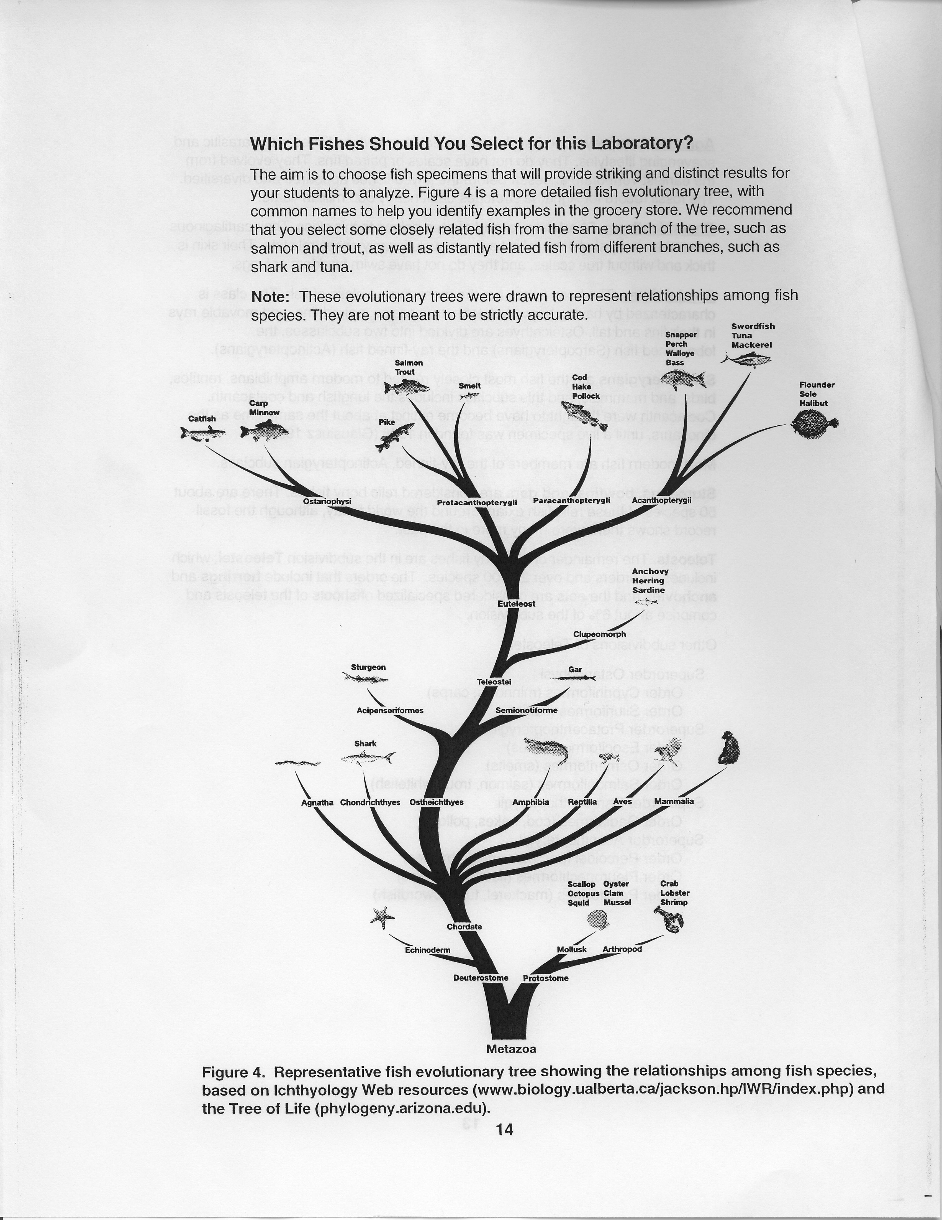
Laboratory Day 3
Gel Preservation
Purpose of this laboratory:
Examine data and make a permanent record
Procedure Overview:
1. Initial examination of protein profiles from fish samples
2. Set up of gels for drying
Step 1 Review Considerations 4 and 5 for interpreting electrophoresis gels
Step 2 Check your workstation for materials and supplies
Step 3 Go
Laboratory Checklist
Student Workstations
Water (tap water) | 1 liter
GelAir cellophane support | 2
Plastic container (if not using GelAir drying frame) | 1
Rubberbands | 2
Teacher's (Common) Workstation
GelAir drying frames | 1
GelAir dryer (optional) | 1
1. Examine your gels. Blue protein bands should be visible on the clear, destained gel. You may want to make a photocopy of your gel so that your data are available to analyze sooner.
Your teacher will tell you if you will be drying your gel with GelAir drying frames, or by the plastic container method. Follow the instructions below accordingly.
Note: For best results, trim off the thick bottom edge of the gel before drying.

GelAir drying frame method:
Prewet 2 sheets of cellophane in a container of water for 15-20 seconds.
2. Place a plastic drying frame on the GelAir assembly table. Center one sheet of cellophane on the assembly table.
3. Carefully lay your gel on the cellophane, positioning it to accommodate other gels (up to 6 total). If there are bubbles between the gel and the cellophane, gently push them out with your gloved finger.
4. Flood the gels with water and lay the second sheet of cellophane on top of them, trying not to trap any bubbles in the sandwich. If there are any bubbles, gently push them out with a gloved finger. Bubbles will cause cracks in the gel during drying!
5. Place the square metal frame on top of the cellophane sandwich. Secure the eight clamps onto the frame, two on each side. If you are not using a GelAir Dryer oven, place the frames upright in a well-ventilated area for 12-36 hours.
If you have a GelAir dryer, place up to four drying frames into the oven, turn the heater switch on and set the dial to 3 hours. The dryer will shut off automatically.
6. When the gels are completely dry, they will be flat. Remove the clamps and take the gel/cellophane sandwich from the frame. Trim the excess cellophane surrounding your dried gel with scissors.
Alternatively, you may use the GelAir cellophane sandwich and plastic container method:
Wet two pieces of cellophane in a large volume of water, around 500 ml. Place one sheet of cellophane over a plastic container. Pull the cellophane taut so that it makes a flat surface over the top of the container, and use a rubber band to secure the sheet in place. Place a gel onto the cellophane. Remove any air bubbles that are under or around the gel. Flooding the surface of the cellophane around the gel with water will aid in the removal of bubbles. Place the second sheet of wetted cellophane over the gel, being careful not to trap any bubbles. Secure the second sheet of cellophane to the box with a second rubber band. Allow gel to dry for several days in a well-ventilated area.
Focus Questions: What Is the Significance of Your Data? What Do the Bands Reveal?
You have completed a procedure that displays a profile of protein composition in the muscle tissue of different fish. Since proteins are a reflection of an organism's DNA, variation in these composition profiles reflects genetic, that is, DNA sequence, variation. Evolutionary relationships among species are inferred from the degrees of genetic (DNA) similarity among them. The protein fingerprints you've generated, indirectly representing the genetic compositions of your chosen fish species, are molecular-level indicators of evolutionary relationships. The conclusions you draw from your own data can be compared to evolutionary relationships based on traditional morphological criteria.

Interpreting the bands collectively: Qualitative comparisons of protein profiles

- Is there any variation among the protein profiles of your samples?
- How would you distinguish the protein profiles of different species from each other?
- What are possible explanations for this variation?
- Which samples are most alike?

Tape your gel or a photocopy of it in the box. The bands are the data upon which your analysis will be based.
Post Laboratory - Quantitative Analysis of Data

The most similar species:

Now that you've had a chance to make a general comparison of the similarities and differences of protein banding patterns among the fish samples you've analyzed, a more quatitative analysis of your data may further support or refute your hypotheses.

1. Before you conducted the investigation, which two fish species did you list as being most related?

______________________________and__________________________

2. Of all the muscle proteins that you found in these two species, how many are present in both species?_________________

3. What is the total number of different kinds of proteins that you were able to detect on your gel, in these two species?__________________

4. Of the total number of proteins in this pool, how many are found in common to both species listed in question 1 above?
(number of proteins in question 2) _{x} 100 =________%
(number of proteins in question 3)

The least similar species:
1. Prior to starting the laboratory, which two fish species did you indicate to be least related?
_____________________________and_____________________________

2. Of all the muscle proteins that you found in these two species, how many are present in both species?_______________________________
3. What is the total number of different kinds proteins that you were able to detect on your gels, in these two species?_________________
4. What percent of the muscle proteins were common to these least similar species?________ %
5. Do your data support the relationships indicated by the phylogenetic tree?
Interpretation of Individual Bands
1. What do the relative positions of the bands on the gel indicate about the proteins in the bands?
2. Are all of the bands of equal thickness?
3. How would you explain the observation that some proteins form thin bands while others form thick bands?
Determining the Molecular Weights of Proteins

Look at the sample gel below. Proteins of known sizes were run along with 5 different fish muscle extracts, which are complex mixtures of unknown proteins. By comparing the migration distance of an unknown protein to that of a series of known molecular weight standards, the size of the unknown protein can be estimated. While it is not possible to determine the exact identity of a particular protein using this technique alone, a good estimate of the protein's molecular weight is obtained.

1 | 2 | 3 | 4 | 5 | 6 | 7

Lane: i . Kaleidoscope standards 2. Shark
3. Salmon 4. Trout 5. Catfish 6. Sturgeon 7. Actin and myosin standard

Figure 21. Protein standards and fish extracts were run on a 15% polyacrylamide Ready Gel at 200 V for 30 minutes, stained with Bio-Safe Coomassie stain, and destained in water.
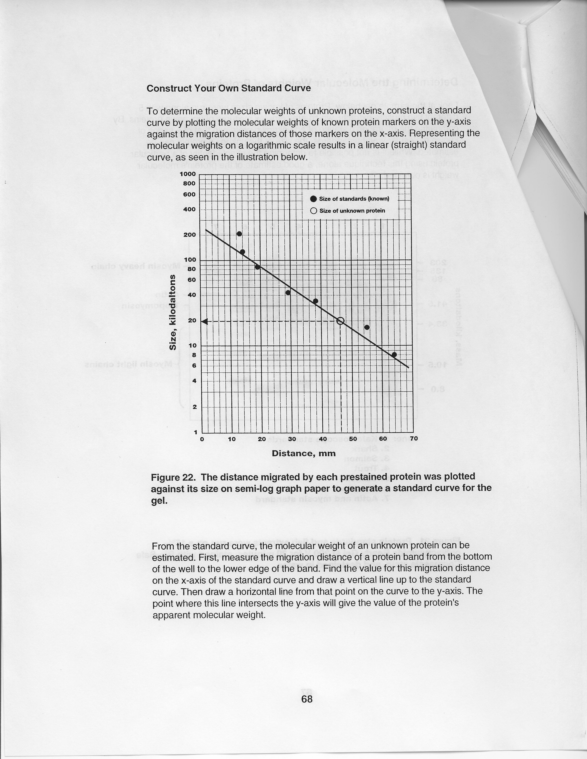
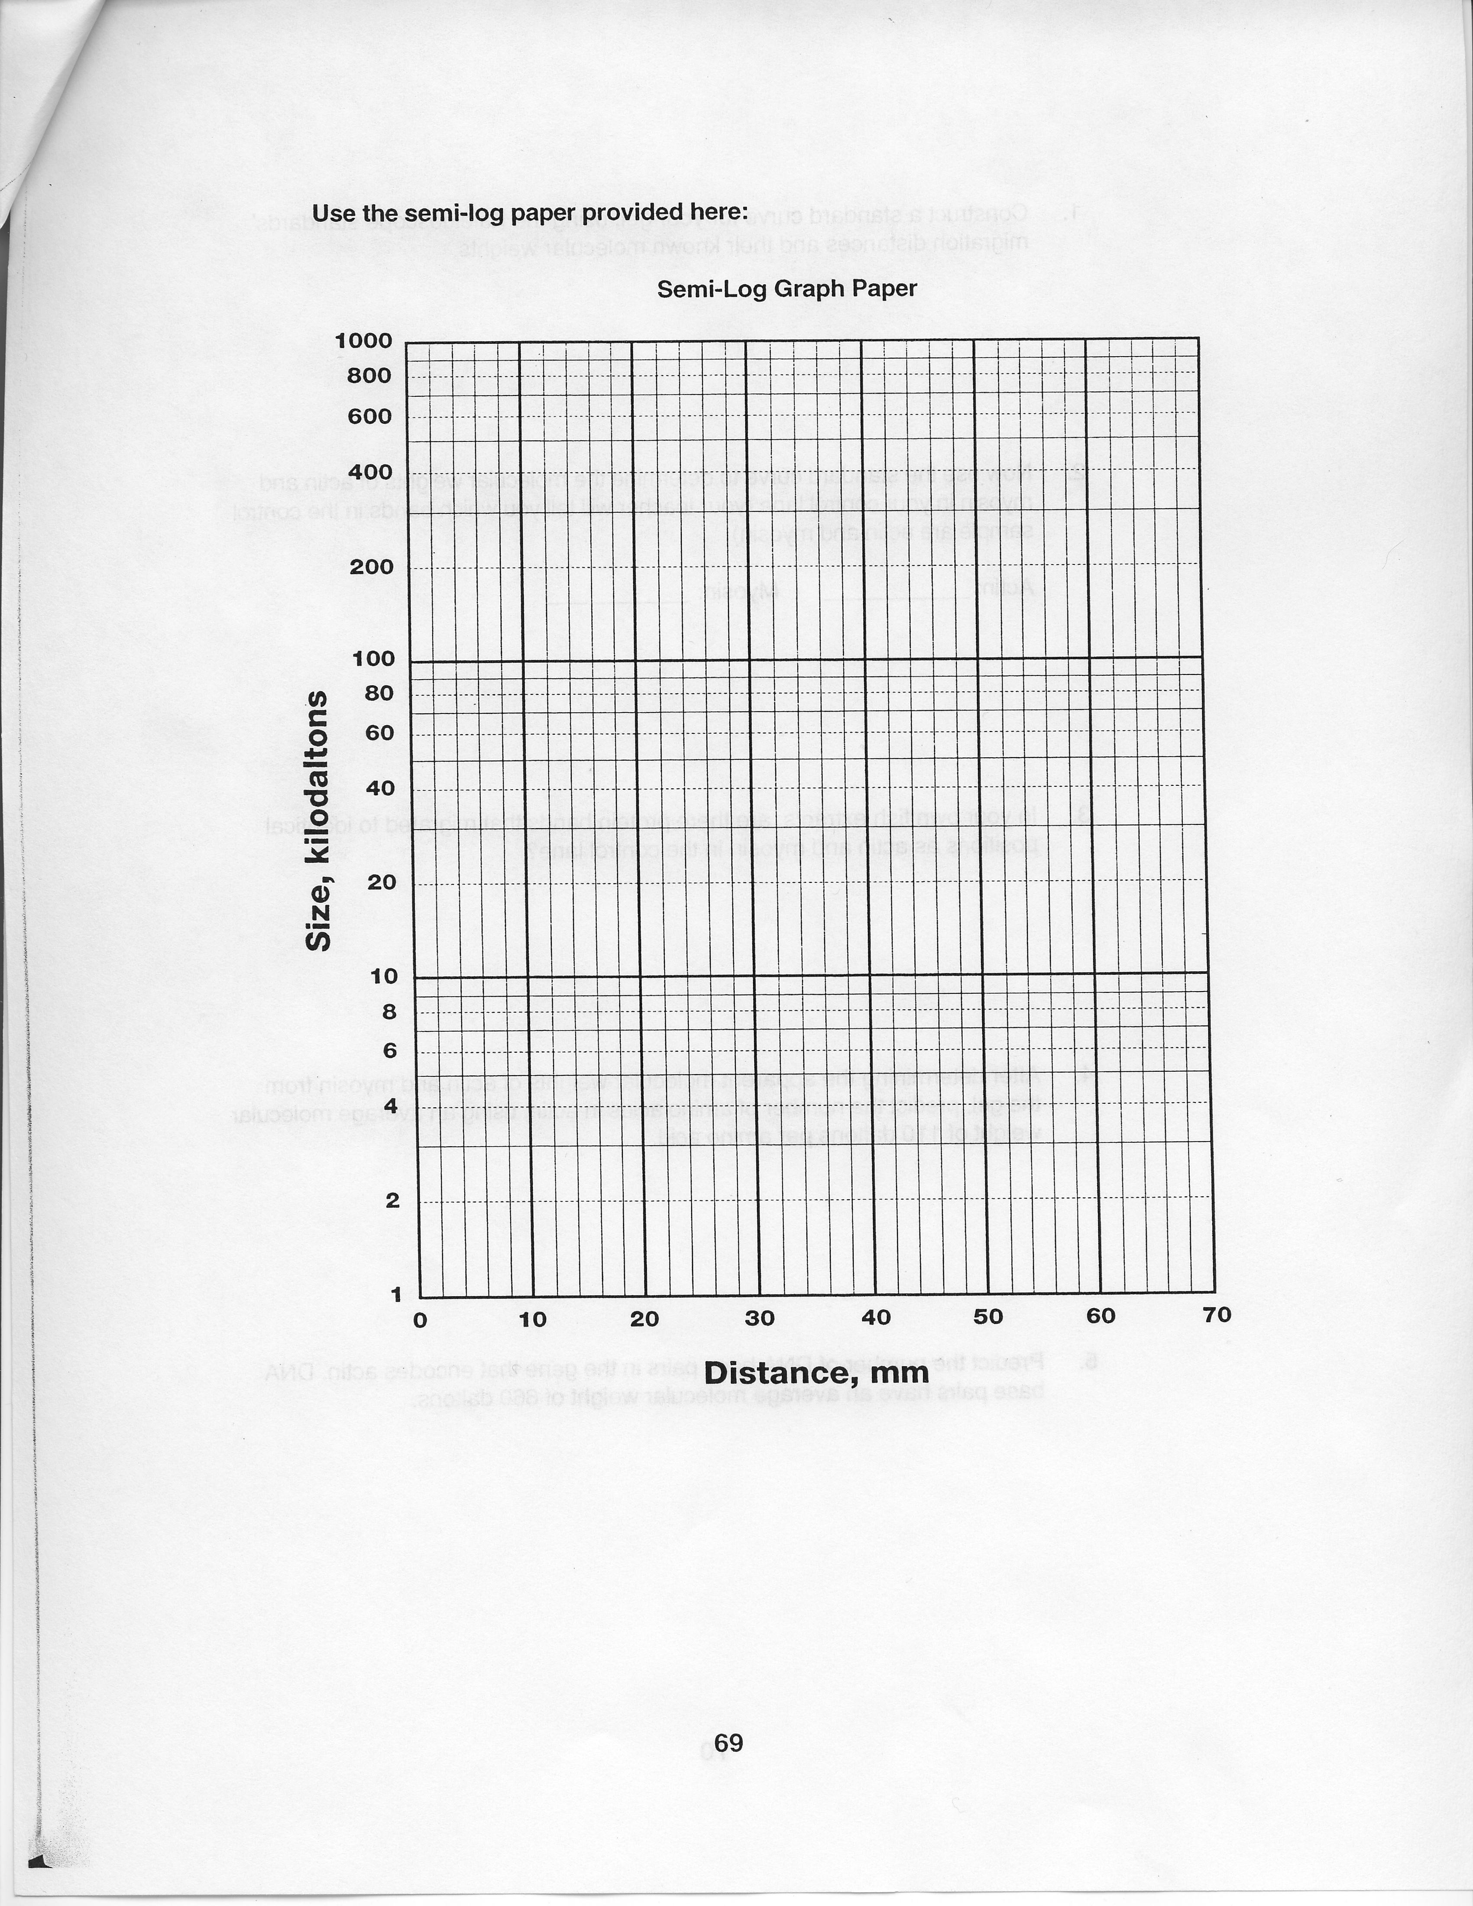
- Construct a standard curve for your gel, using the Kaleidoscope standards' migration distances and their known molecular weights.

- Now use the standard curve to determine the molecular weights of actin and myosin in your control lane (your teacher will tell you which bands in the control sample are actin and myosin)
Actin:_______________ Myosin:________________
- In your own fish extracts, are there protein bands that migrated to identical positions as actin and myosin in the control lane?
- After determining the apparent molecular weights of actin and myosin from the gel, predict the number of amino acids in actin, using an average molecular weight of 110 daltons per amino acid.
- Predict the number of DNA base pairs in the gene that encodes actin. DNA base pairs have an average molecular weight of 660 daltons.

- Compare answers obtained by the class for questions 1-5. Are there differences? What information would you need to determine actual molecular weights, and numbers of amino acids and DNA base pairs?
- Why might the apparent weights you have determined from your gel differ from the true molecular weights of actin and myosin?
- Would you expect the molecular weight approximations that you have determined from your gel and standard curve to be closer to true values for larger or smaller proteins? Why?
9. Describe the relative concentrations of actin and myosin in your fish samples.
10. Actin and myosin are proteins found in muscle tissue of all animals. Based on your data, what can you say about these two proteins in the fish you have investigated? What might you find if you looked at actin and myosin in other animals?

The following is a list of the proteins common to all animal muscle, adapted from Alberts et al. 1994.
Protein | MW (in kD) | Function
titin | 3000 | centers myosin in sarcomere
dystrophin | 400 | anchoring to plasma membrane
filamin | 270 | cross-links actin filaments into gel
myosin heavy chain | 210 | slides actin filaments
spectrin | 265 | attaches actin filaments to plasma membrane
M1/M2 | 190 | myosin breakdown product
M3 | 150 | myosin breakdown product
C protein | 140 | myosin breakdown product
nebulin | 107 | regulates actin assembly
a-actinin | 100 | bundles actin filaments
gelsolin | 90 | fragments actin filaments
fimbrin | 68 | bundles actin filaments
actin | 42 | forms filaments
tropomyosin | 35 | strengthens actin filaments
troponin (T) | 30 | regulates contraction
myosin light chains | 24, 17, 15 | slides actin filaments
troponin (I) | 19 | regulates contraction
troponin (C) | 17 | regulates contraction
thymosin | 5 | actin monomers

11. Based on these molecular weights provided, can you guess the identities of any of the proteins in your gel?
12. Can you definitively assign the identity of a protein based on its molecular weight? Why or why not?
13. Do all of your samples have similar band profiles? How can you explain the variation in the muscle protein profiles of different fish species?
14. Describe the relative concentrations of some of the proteins in your samples.
15. Given what you know about the fish species you selected for this study, e.g., their habitats, lifestyles, and presumed evolutionary relationships, what might be the functions of some of the proteins you can't identify? Use your imagination.

Conclusions
1. You have isolated, separated, and compared profiles of muscle proteins from a number of different fish species. You have also correlated the similarities of these protein profiles with the species' presumed phylogenetic relationships. What do protein profiles tell us about DNA similarities among species? Be as explicit as possible.
2. What implications might these kinds of molecular data have in relation to the theory of evolution?
3. Do your data correlate with the arrangement of branches of the evolutionary tree?
4. What new questions or investigations might be stimulated by your findings in this activity?
5. Suppose someone tells you they don't understand the evidence for the theory of evolution, since no one has been able to witness the process of species evolving through time. How would you use your experimental data to respond to their statement?
Science in Motion Clarion University Materials List
Lab: "There's Something Fishy about Evolution"
Equipment | Quantity |  |  | Delivered | Returned
Vertical
electrophoresis
chamber
Loading guide
10~t1 fixed volume
pipettor
Light box
Heater
Digital Thermometer
Knife to cut fish
Powerpoint
presentation, laptop,
projector unit
Consumables |  | Quantity | Delivered |  |  | Returned
Fish samples
Polyacrylamide gel
Distilled Water
Pipet tips
Fliptop micro test
tubes
Screwcap micro test
tubes
Laemmli sample
buffer
Kaleidoscope
restained standards
10x tris-glycine-SDS
buffer
Coomassie stain
Actin and myosin
standards
Gel staining trays
Floating microtube
rack
Permanent markers
Gloves/goggles |  |  |  |  |  | .
Student Lab Copy = Student Evaluations=
Teacher Lab Copy= Teacher Evaluations=

