Need a Ride Home This Thanksgiving?

Bus to Harrisburg, King of Prussia & Philadelphia
Leave: Tuesday, November 21, 2017
Return: Sunday, November 26, 2017

Bus departs from outside Tippin Gym at 3:00 PM on Tuesday, November 21, 2017

- Your original sign-up for buses will be final. NO EXCEPTIONS!
- NO REFUNDS! Cost: Harrisburg, King of Prussia, Philadelphia – $85.00
- Clarion University is not responsible for lost, stolen, or damaged luggage.
- BAGGAGE RESTRICTIONS WILL BE STRICTLY ENFORCED!
- Anyone attempting to load trunks, stereos, television sets, refrigerators, etc. will be instructed to remove these items from the bus. The bus will not be held in order to enable you to find space for such items. EACH PASSENGER IS PERMITTED TO TRAVEL WITY ONLY ONE SUITCASE AND ONE CARRY-ON BAG.
- Food stops – follow instructions. Buses won’t wait for stragglers.
- NO SMOKING - PERSONAL (HEADPHONE) STEREOS ONLY.
- PHOTO ID REQUIRED TO BOARD BUS. (DEPARTURE & RETURN TRIPS)

Sign Up in the CSA Office - 278 Gemmell
Cost to Ride: $85.00
*Clarion University is not responsible for lost, stolen, or damaged luggage*
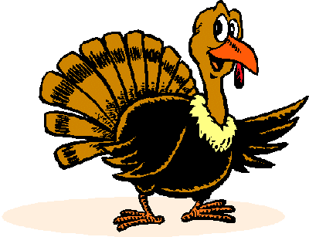
Pick-Up & Drop-Off Locations:

Clarion – Outside of Tippin Gymnasium
Harrisburg – I-83 South, Union Deposit Exit, Texaco Station, Lowes
King of Prussia – King of Prussia, Shopping Center, Crates–n-Barrel
Philadelphia – 30TH Street Station

Departure & Return Times:

Departure – Tuesday, November 21, 2017

3:00 PM | 7:00 PM | 8:30 PM | 9:15 PM
Depart | Arrive | Arrive | Arrive
Clarion University | Harrisburg | King of Prussia | Philadelphia

Return – Sunday, November 26, 2017

2:00 PM | 3:00 PM | 4:30 PM | 8:30 PM
Depart | Arrive | Arrive | Arrive
Philadelphia | King of Prussia | Harrisburg | Clarion University

Questions?
Please Contact the Clarion Students’ Association Office at 814-393-2423 or csa@clarion.edu
Bus Company: Fullington Trailways & VIP Limousine
814-355-4900 www.fullingtontours.com

Clarion University and the Clarion Students' Association hereby give notice that all arrangements for accommodations and/or transportation and/or activities are made upon the express condition that they shall not be liable for any injury, damage, loss, accident, delay, or other irregularity which may be occasioned during this trip. The right is reserved to cancel the trip if there are an insufficient number of participants. If cancelled, all monies will be refunded.
In purchasing this seat, the bus patron acknowledges his or her responsibility to be aware of and abide by all bus trip policies and procedures and all relevant University policies and local, state, and federal laws. This includes but is not limited to the illegal use and/or transport of controlled substances (alcohol and/or drugs) as a patron of this bus trip. Such use and/or transport will result in immediate judicial action by CUP and criminal action by the appropriate authority (ies.) As a condition of their chartered contract, the driver of the bus is required to report all violations of University policy and local, state, and federal law to the Clarion Students' Association office and organizations. The bus patron must bear in mind that his/her person and property are subject to search by duly warranted law enforcement officers at any time. Clarion Students Association is not responsible for lost, stolen, or damaged luggage.
I have read and fully understand the terms and conditions outlined above and BY MY SIGNATURE I ACCEPT FULL RESPONSIBILITY FOR ADHERING TO THEM.

___________________ ______________________________
(Date) (Student Signature)
______________________________
(Local Phone Number)

