PROFESSIONAL ASSOCIATIONS

NIRSA & PIRSA
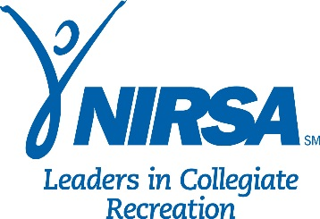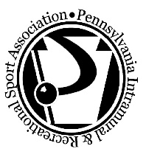
Students can also get involved with other intramural tournaments through PIRSA (Pennsylvania Intramural-Recreational Sports Association) and NIRSA (National Intramural-Recreational Sports Association). Events are held on various regional, state and national levels.

William N. Wasson Student Leadership & Academic Award Winners
The William N. Wasson Student Leadership & Academic Award recognizes top students in collegiate recreation who participate in or are employed by the Department of Recreational Sports. Apply Annually. A Clarion student, Kassie Leuschel, won this award in 2009

