Emergency Numbers

CCR Clarion County Crisis (Walk in 9-4, 214 S 7th Ave)
814 226 7223
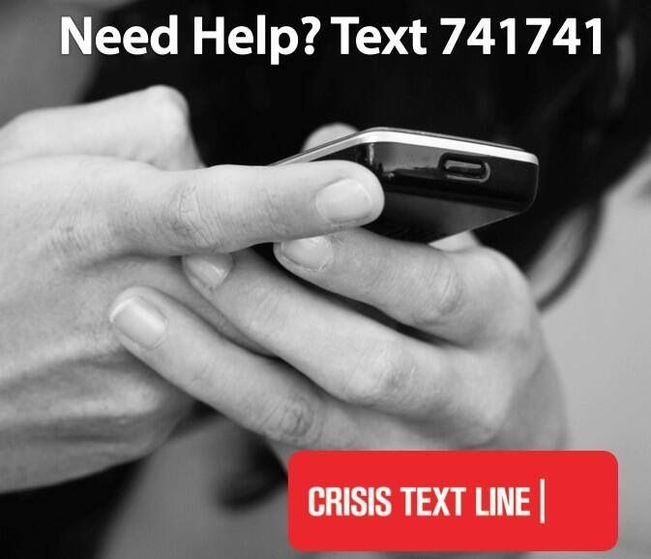
Clarion Psychiatric Center
800 253 4906

Campus Police
814 393 2111

Clarion County Emergency
911

National Suicide Prevention Lifeline
800 273 8255

Community Mental Health Agencies
Primary Health Network
814 223-9914

Clarion Family Therapy
814 227 2941

Family Psychological Services
814 226 4912

SAFE
800 992 3039

Passages
800 793 3620

Emergency Numbers

CCR Clarion County Crisis (Walk in 9-4, 214 S 7th Ave)
814 226 7223
Clarion Psychiatric Center
800 253 4906

Campus Police
814 393 2111

Clarion County Emergency
911

National Suicide Prevention Lifeline
800 273 8255

Community Mental Health Agencies
Primary Health Network
814 223-9914

Clarion Family Therapy
814 227 2941

Family Psychological Services
814 226 4912

SAFE
800 992 3039

Passages
800 793 3620

