Research and Internship Experiences

The History Department encourages students to seek out research and internship experiences. Such high impact practices reinforce the learning of History and provide students with practical experience.

The curriculum of the History major provides two Writing Intensive Research Seminars (Hist. 298 and Hist. 410) that train History students in the writing of works of academic research. We encourage students to present their research papers in oral form to different venues such as the regional conference of Phi Alpha Theta (the national History honorary society) and the Undergraduate Research Conference at Clarion University (see pictures of examples below).
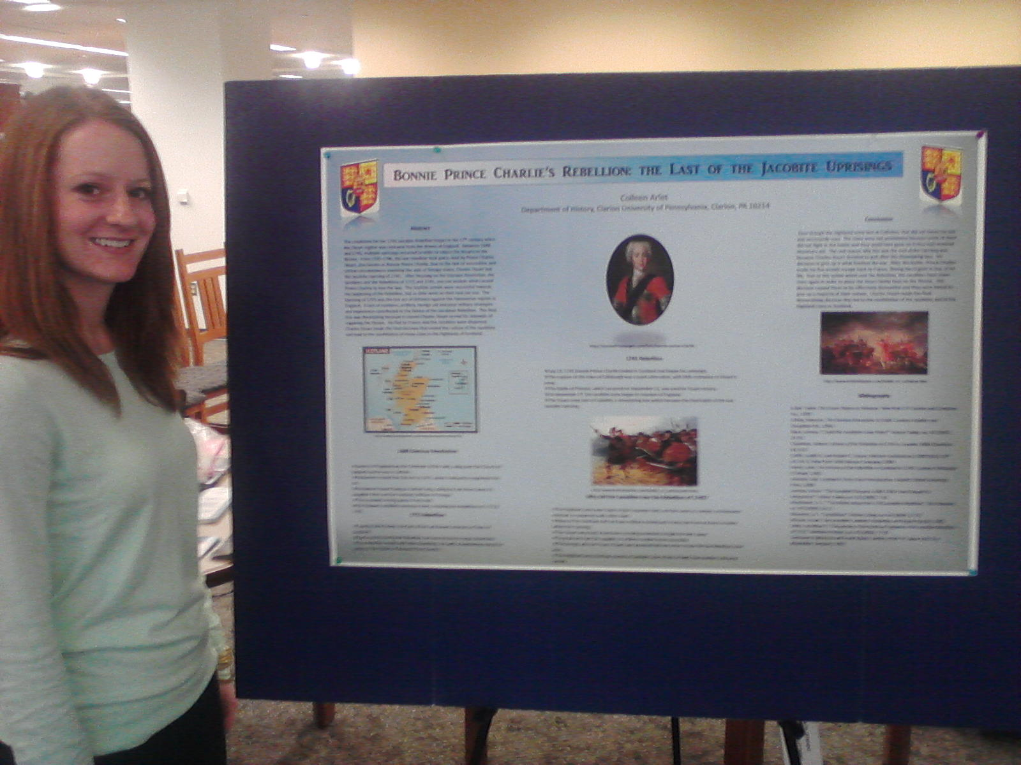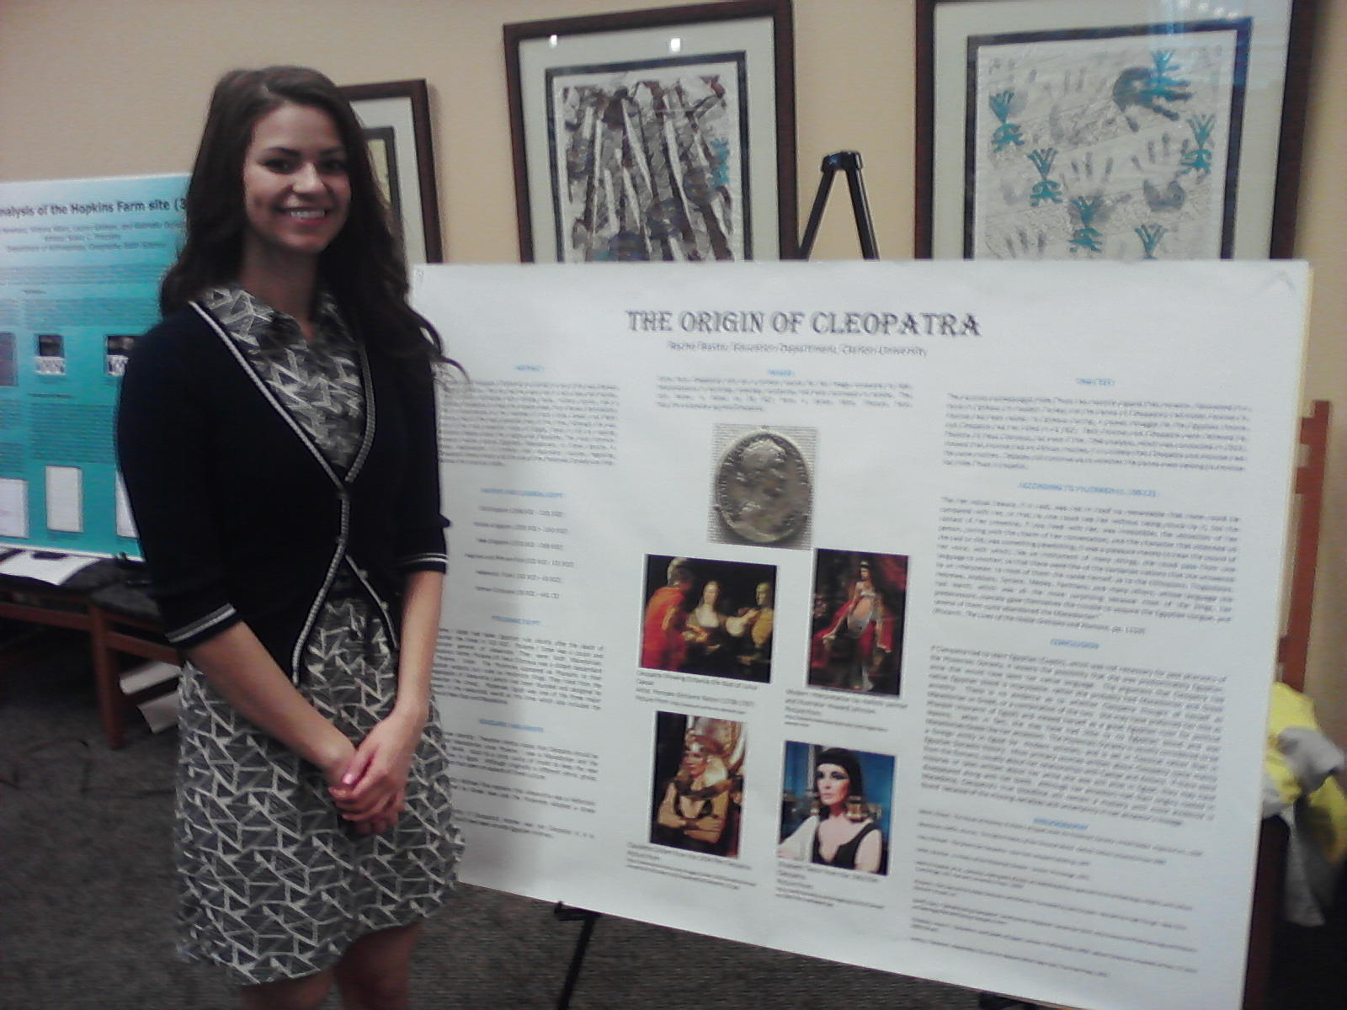

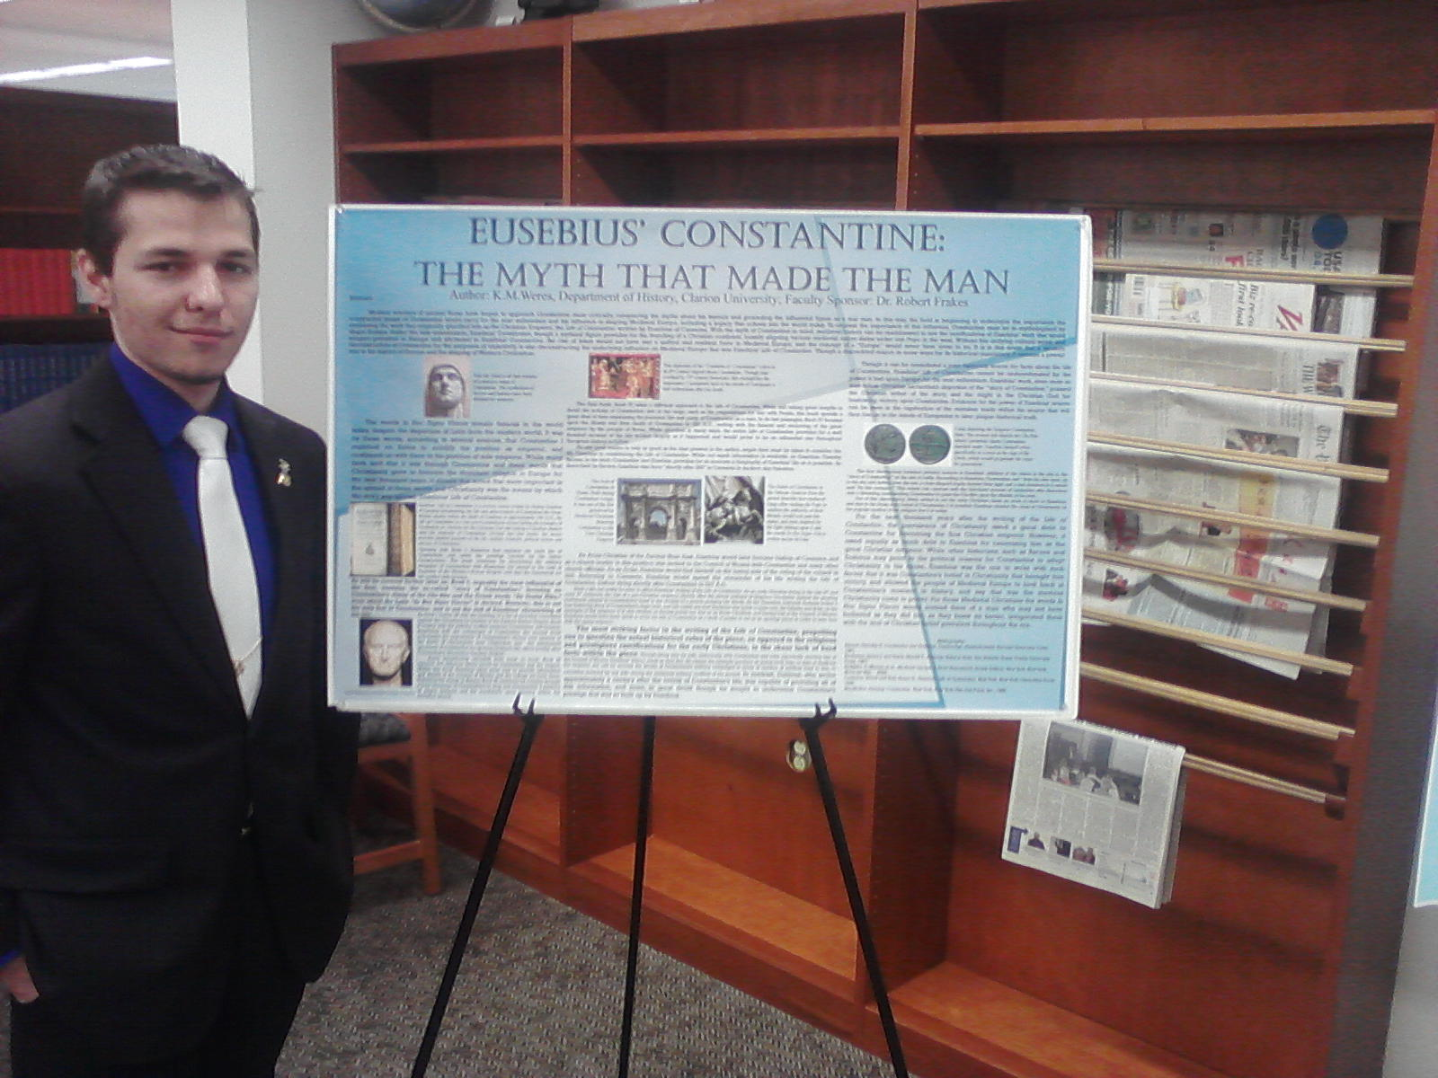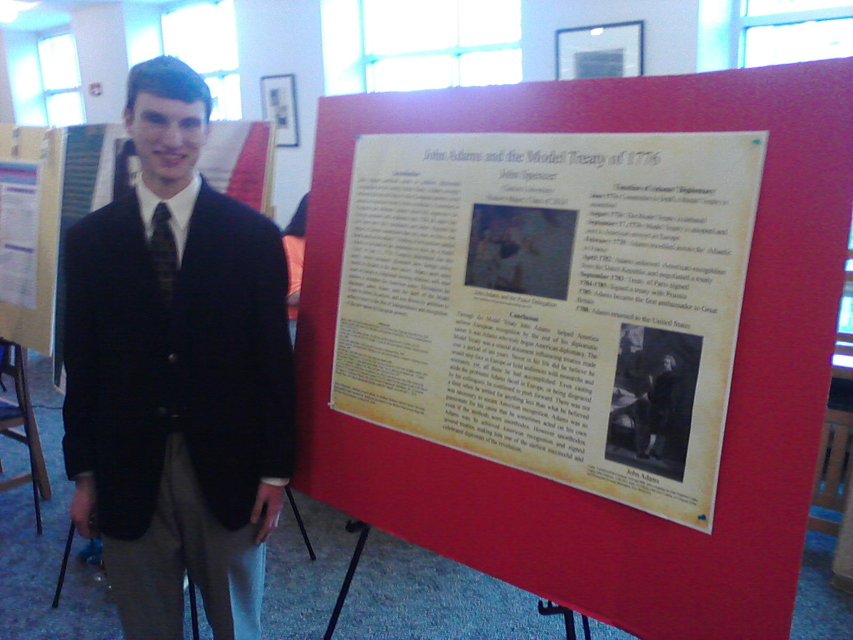

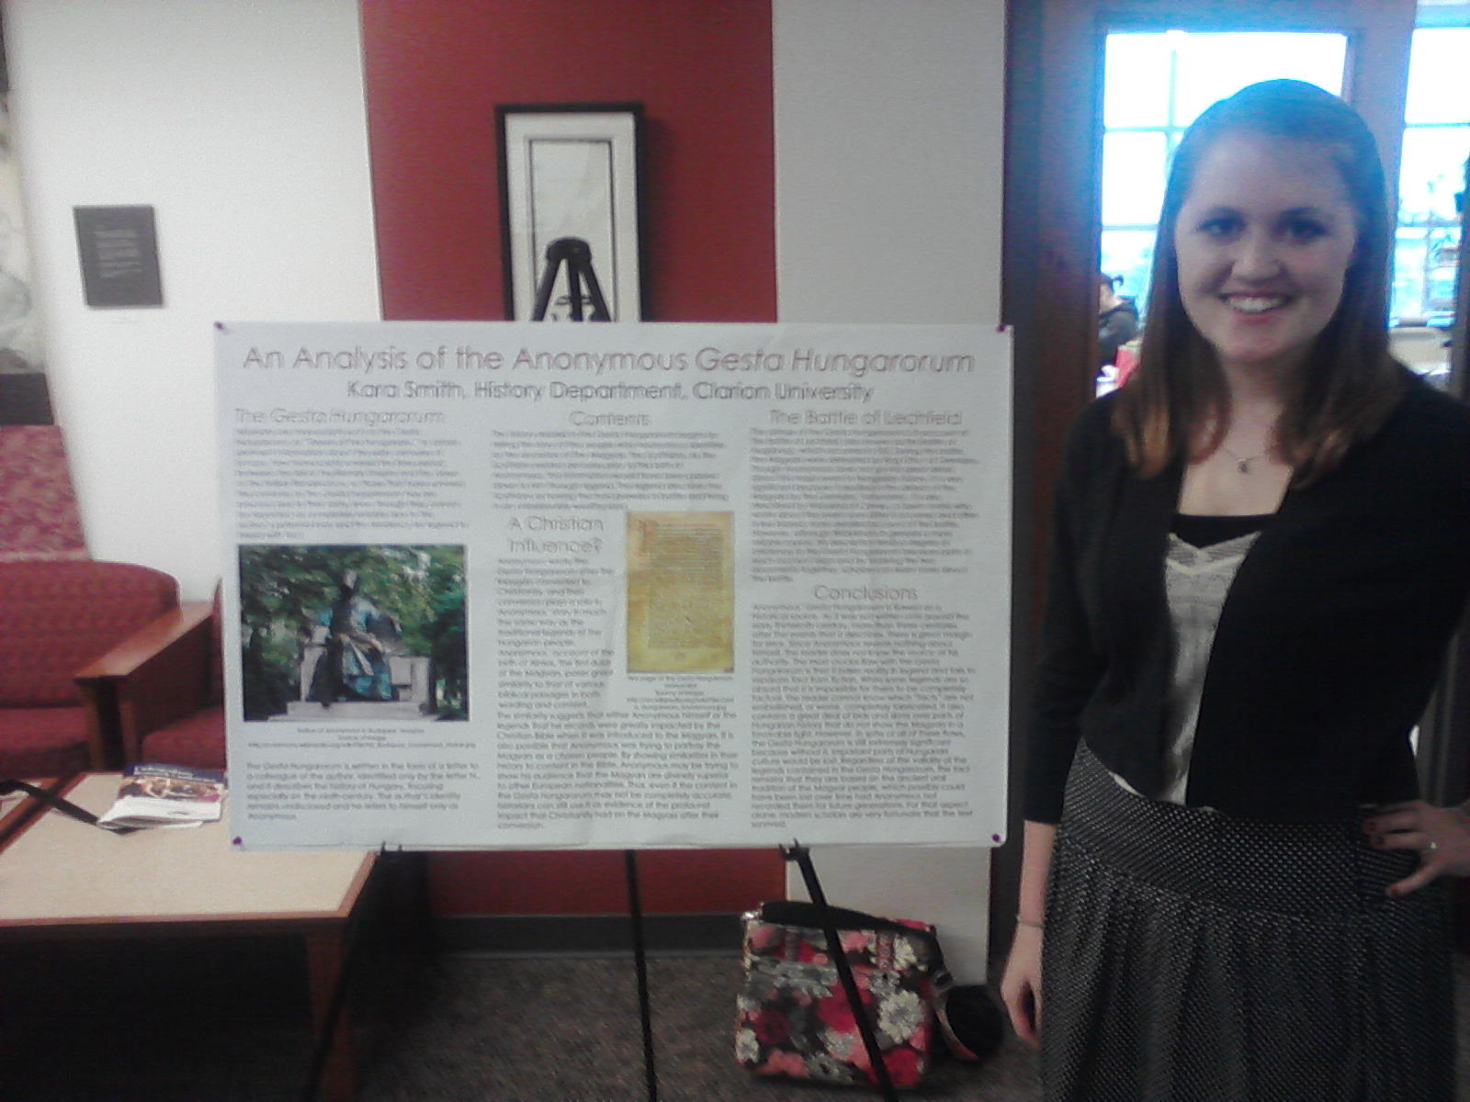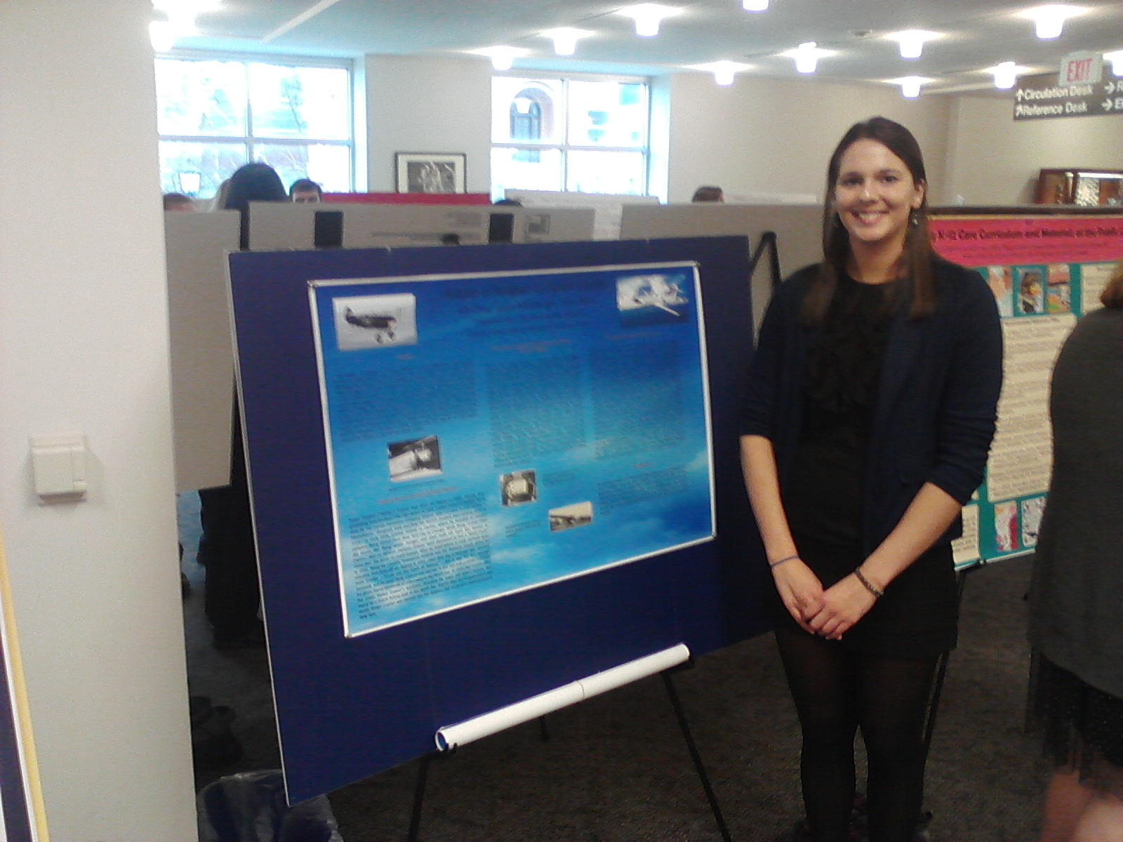

Students interested in possible careers in museum administration have sought out internships with local historical societies (in Clarion and Brookville) as well as in museums in the region (such as in Titusville and Pittsburgh), and beyond. Students interested in such internships should contact Dr. Todd Pfannestiel in the History Department who also oversees the Clarion History Project where students can gain hands on experience in local history.

