Pharmacies  CVS (814) 226 7138  Marianne Pharmacy (814) 226 5353  Walmart Clarion Pharmacy (814) 226 0901 (814) 226 4015  Physical Therapists  Clarion Rehab (814) 226 8002  Anderson Physical Therapy (814) 223 4090  Phoenix (814) 297 8093  Drug/ Alcohol Services  CenClear (814) 226 4171  Armstrong-Indiana-Clarion Drug and Alcohol Commission (814) 226 6350 |  |  | Women’s Services  Next Step Pregnancy Solutions & Service (814) 226 7007  Women, Infants, and Children’s Program (WIC) (814) 226 8130  Family Practice  Brooks Medical Arts (814) 226 7651  Marianne Family Practice (814) 226 6770  Clarion Community Health Center (814) 223 9900  UPMC Northwest Community Medicine (814) 227 1221  Veteran’s Services  Clarion County Dept of Veterans Affairs (814) 226 4000  Clarion County VA Outpatient Clinic (814) 226 3900  Butler VA (800) 362 8262  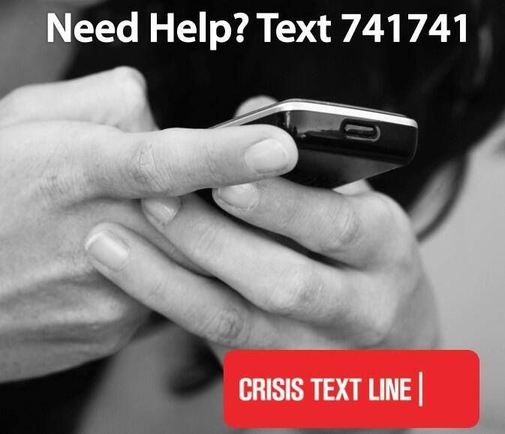 |  |  | Wellness Resource Guide  - Clarion University Center for Wellness

Clarion University  Counseling Services (814) 393 2255  Health Services (814) 393 2121  Public Safety (814) 393 2111  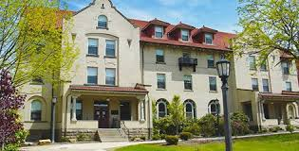  Crisis Numbers  Borough Police 911  Campus Police (814) 393 2111  Clarion County Crisis (24/7 availability) (814) 226 7223  Chiropractors  The Rehab Center (814) 226 8002  Applewood Chiropractic (814) 226 5441  Dentists  Applewood Center (814) 226 6321  Clarion Dental Care (814) 223 9968  Drew Hawk (814) 227 2160  Clarion Dental Center (814) 223 9906 |  |  | Center for Wellness is located at 256 Becht Hall  Counseling & Student Support Services  814 393 2255  Walk-in Hours Monday-Thursday  9am-11:15am & 1pm-3pm  Friday by appointment  Students interested in counseling, experiencing a crisis, or who are looking for someone to talk to about issues or concerns are welcome to utilize the walk-in hours.  Health Services  814 393 2121  Open Monday – Friday 8:30am – 5pm  FULL SERVICE HEALTH CLINIC  Common Reasons for Appointments  Women’s Health Services, Immunizations, Allergy Clinic, Physicals, Routine Visits, STI Screenings, Strep Testing, Mono Testing, Flu Tests, Treatment of Injuries and Illness |  |  | Mental Health  Clarion Psychiatric Center (800) 253 4906  Clarion Behavioral Health (814) 223 9914  Family Therapy Services (814) 227 2941  Family Psychological Associates (814) 226 4912  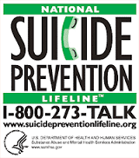  Optometrists  Victor Cherico (814) 226 9441  Dirk Vandermeer (814) 226 9505  Kelly Owens & Joshua Diehl (814) 226 4862  Wal Mart Vision Center (814) 226 0909

