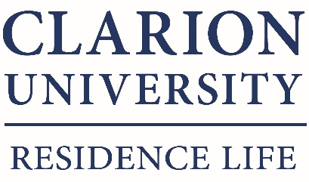

Fall 2020 Semester Break Closing Notice

All students in Campus housing will need to leave their building by Friday November 20, 2020 by 6pm to work remotely for the remainder of the fall 2020 semester. The Semester Break begins at 10:00 p.m. on Friday, December 4, 2020. Residents should look to their student emails the by the week of January 4th 2021 for information about coming back into housing for the spring semester. Classes resume Monday, January 25, 2021.

Residence Halls Closing
All residence halls close at 6:00pm on Friday, November 20, 2020. All residents must be out of the building at this time. If you find it impossible to leave the building by the time stated above, PLEASE SEE YOUR HALL Staff – (Wandy Ortega-Lopez for Campus View and Valley View; Corey Negley for Suites on Main North and Suites on Main South) by 6:00pm on Thursday, November 19, 2020 to discuss alternatives.

If you need housing for the break period or any portion of it, please complete the “Break Housing Request Form” and email to the office of Residence Life Services at reslife@clarion.edu. Students are not permitted to remain on-campus during the break without permission from Residence Life Services.

Preparing Your Room Before Leaving for Break
Please prepare your room as outlined below before leaving campus.
- Close and lock your windows
- Leave your drapes/window coverings open
- Gather and empty all trash
- Unplug ALL electrical cords
- Unplug, defrost, and wipe out refrigerators. Any water leakage that causes damages will be assessed if defrosted improperly. It is recommended that you defrost your refrigerator 24-48 hours before you leave for break.
- Throw away perishable foods.
- SOMN/SOMS/Campus View/Valley View residents – turn your heat/AC to 65 degrees on the heat setting
- Doors to wall unit heaters need to be cleared so maintenance can inspect heating units during the break
- Open doors under your sink.
- Leave your bathroom door open.
- Turn off lights
- Lock room door (and bedroom door if in a Suite)
- Sign the break sheet on your door

Failure to comply with these instructions will result in documentation. You and/or your roommate will be considered in violation of the University conduct code if any residence hall/university policy violations are found in your room.

Please Note: The University assumes no responsibility for personal belongings left in student rooms during break periods. You may want to consider taking your computer equipment, stereo equipment, etc. home with you over the break.

If you are transferring or withdrawing, going online and not residing in campus housing for Spring 2021 semester:
If are transferring, going online and not residing in campus housing for spring 2021 semester, or leaving the University after the fall semester, please complete the Contract Release Request Form and submit to Residence Life Services at reslife@clarion.edu. You should also contact your hall staff: Wandy Ortega-Lopez - Campus View and Valley View Suites; Corey Negley-Suites on Main South and Suites on Main North, by Friday November 13th, 2020. There is a process to complete to check-out of your housing assignment appropriately and/or withdrawal from the university to be sure you do not acquire any fees.

Thank you and please contact a Residence Life hall staff member if you have any questions.

